WOMEN’S LANGUAGE FEATURES USED BY THE MAIN CHARACTER OF THE RADIOACTIVE (2019) MOVIE

A THESIS

BY
SYIFA NADIAH KHANSA
REG. NO. 200705123



DEPARTMENT OF ENGLISH
FACULTY OF CULTURAL SCIENCES
UNIVERSITAS SUMATERA UTARA
MEDAN 2025

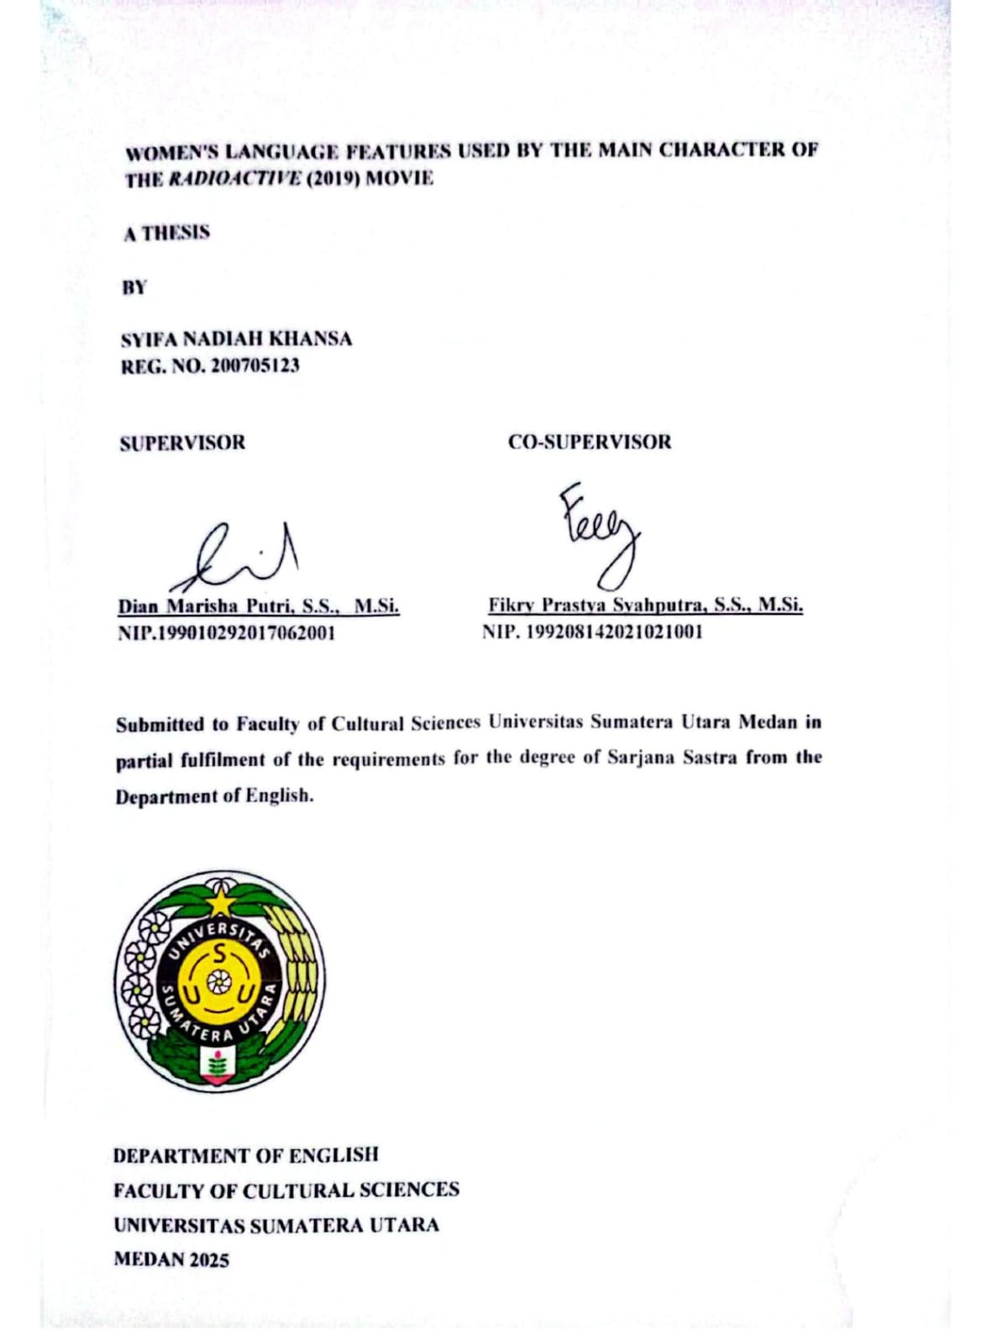
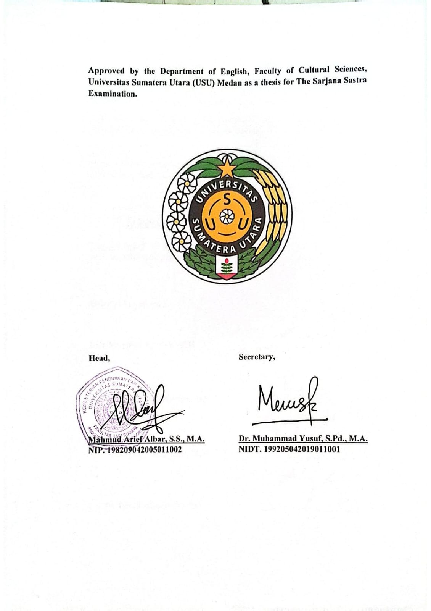

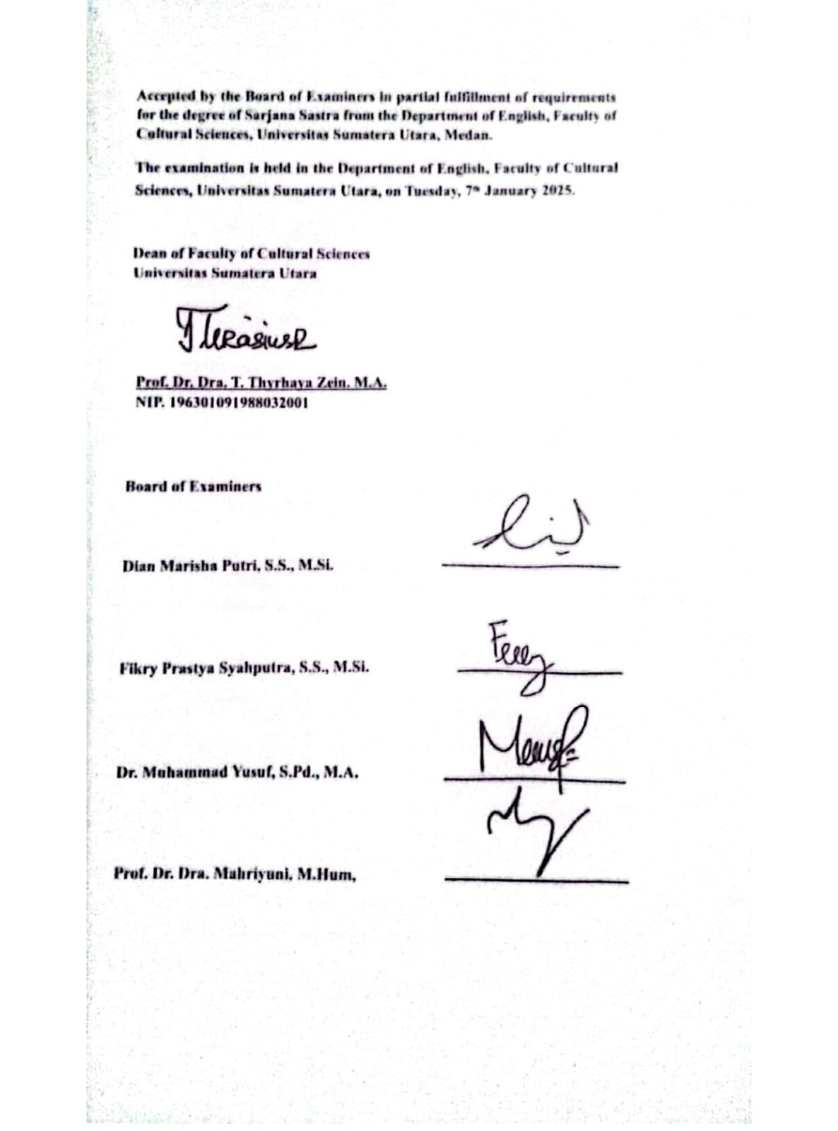

AUTHOR’S DECLARATION

I, SYIFA NADIAH KHANSA, DECLARE THAT I AM THE SOLE AUTHOR OF THIS THESIS EXCEPT WHERE REFERENCES IS MADE IN THE TEXT OF THIS THESIS. THIS THESIS CONTAINS NO MATERIAL PUBLISHED ELSEWHERE OR EXTRACTED IN WHOLE OR IN PART FROM A THESIS BY WHICH I HAVE QUALIFIED FOR OR AWARDED ANOTHER DEGREE. NO OTHER PERSON’S WORK HAS BEEN USED WITHOUT DUE ACKNOWLEDGEMENTS IN THE MAIN TEXT OF THIS THESIS. THIS THESIS HAS NOT BEEN SUBMITTED FOR THE AWARD OF ANOTHER DEGREE IN ANY TERTIARY EDUCATION.

Signed :

Date : January 8th, 2025

COPYRIGHT DECLARATION

NAME : SYIFA NADIAH KHANSA
TITLE OF THESIS : WOMEN’S LANGUAGE FEATURES USED BY THE MAIN CHARACTER OF THE RADIOACTIVE (2019) MOVIE
QUALIFICATION : S-1 / SARJANA SASTRA
DEPARTMENT : ENGLISH LITERATURE

I AM WILLING THAT MY THESIS SHOULD BE AVAILABLE FOR REPRODUCTION AT THE DISCREATION OF THE LIBRARIAN OF DEPARTMENT OF ENGLISH, FACULTY OF CULTURAL STUDIES, UNIVERSITY OF SUMATERA UTARA ON THE UDERSTANDING THAT USER ARE MADE AWARE OF THEIR OBLIGATION UNDER LAW OF USE REPUBLIC OF INDONESIA.

Signed:

Date : January 8th, 2025

ACKNOWLEDGMENT

First and foremost, I would like to express my heartfelt gratitude to Almighty God, Allah SWT. It is by His grace that I have successfully navigated this journey and reached this point with strength and perseverance. I am deeply thankful for His blessings, including a steadfast heart and the presence of loving and supportive people in my life.

I express my thanks to Prof. Dr. Muryanto Amin S. Sos, M.Sc., as the Rector of Universitas Sumatera Utara, Prof. Dr. Dra. T. Thyrhaya Zein M.A., as the Dean of Faculty Cultural Sciences, Mahmud Arief Albar S.S., MA., as the Head of English Department and Dr. Muhammad Yusuf S.Pd. M. A., Secretary of the English Department. I also extend my appreciation to all the lecturers who have imparted invaluable knowledge throughout my studies.

I also would like to express my gratitude to my supervisors, Ma’am Dian Marisha Putri, S.S., M.Si., for her patience, kindness, and guidance in helping me develop ideas and compile my thesis. I also extend my heartfelt thanks to Sir Fikry Prastya Syahputra, S.S., M.Si., my co-supervisor, for his invaluable support and contributions in perfecting my thesis. A great respect I hold for both of my supervisors and am truly grateful for their advice, suggestions, and constructive criticism, all of which have been instrumental in shaping this work.I also don't forget to thank the examiners, Dr. Muhammad Yusuf S.Pd. M. A. and Dr. Dra. Mahriyuni M.Hum. for their thoughtful suggestions and constructive criticism, which have been very helpful in enhancing the quality of my thesis.

Then, my most sincere thanks go to my beloved family: Ayah, Bunda, Ibuk, and Anggi. To Ayah, my pillar of strength and a fighter on my journey—thank you for doing everything in your power to help me stand on my own feet and become the person I am today. Thank you for accepting me for who I am, never complaining about what I perceive as my failures, and being patient throughout my journey. To my mother, whom I lovingly call Bunda—a strong woman who brought me into this world—thank you for the opportunity to be your daughter, for your endless pride in me, for your advice, and for comforting me when I was at my lowest. Thank you for always caring for me, even though I'm not within reach of your hand.To my other strong woman, Ibuk, who is more than just "an aunt" but a mother figure in my life—thank you for being patient with me, for giving me the love of a mother in our home, for embracing me when I was sad, and for supporting my choices unwaveringly. To my wonderfully annoying yet loving younger sister, Anggi—thank you for accepting me as I am, comforting me when I’m anxious, and helping me in countless ways. I may annoy you, but please know that I love you. For my family, I pray for Allah's blessings to always be upon you, for His protection to surround you, and for His grace to bring you happiness.

Lastly, I want to express my thanks to my dearest friends: Alya, Erin, Sabil, Grace, Dinda, and Farhaz, for allowing me to be part of your journey during college. Your presence made my college life more colorful and bearable. Thank you for your support and motivation. To my best friend who is miles away, yet always there for me—Akmal, thank you for being a witness to my journey and for accompanying me even during the toughest times. I would also like to thank my other highschool friends: Icha, Lala, Aul, and Nisa who have been the main contributors to the beautiful memories that I always recall whenever I am at my lowest point.

Medan, December 2024

Syifa Nadiah Khansa
Reg. No. 200705123

ABSTRACT

This research investigates the women’s language features used by Marie Curie, the main character in the film Radioactive (2019). It aims to identify these features, explore the reasons behind their use, and analyze the language functions reflected in her utterances. The study examines whether her position as the only female scientist of her time influenced her language use. This researchused a descriptive qualitative method , with data collected from Marie Curie's utterances, which were analyzed using the framework of women's language features.The findings reveal that Marie Curie employs six out of ten identified features of women's language. The most frequently used feature is rising intonation on declaratives, with eight (8) out of twenty three (23)data. This is followed by four (4)data each of tag questions and superpolite forms, three (3)data of lexical hedges, and two (2)data each of intensifiers and hypercorrect grammar. The analysis suggests that her use of these features is influenced by feelings of uncertainty, likely stemming from the lack of validation she experienced as the sole female scientist in a male-dominated field.

Keywords: Movie, Radioactive, Sociolinguistics, Women’s Language features

ABSTRAK

Penelitian ini menyelidiki fitur bahasa perempuan yang digunakan oleh Marie Curie, tokoh utama dalam film Radioactive (2019). Hal ini bertujuan untuk mengidentifikasi ciri-ciri tersebut, mengeksplorasi alasan di balik penggunaannya, dan menganalisis fungsi bahasa yang tercermin dalam ucapannya. Studi ini mengkaji apakah posisinya sebagai satu-satunya ilmuwan perempuan pada masanya memengaruhi penggunaan bahasanya. Penelitian ini menggunakan metode deskriptif kualitatif, dengan data yang dikumpulkan dari ujaran Marie Curie, yang dianalisis menggunakan kerangka fitur bahasa wanita. Temuan ini mengungkapkan bahwa Marie Curie menggunakan enam dari sepuluh fitur bahasa perempuan. Fitur yang paling sering digunakan adalah “rising intonation on declarative”, dengan delapan (8) dari dua tiga (23) data. Diikuti oleh empat (4) data yang masing-masing berisi “tag question” dan “superpolite form”, tiga (3) data “lexical hedges”, dan dua (2) data yang masing-masing berisi “intensifier” dan “hypercorrect grammar”. Analisis tersebut menunjukkan bahwa penggunaan fitur-fitur ini dipengaruhi oleh perasaan ketidakpastian, kemungkinan besar berasal dari kurangnya validasi yang ia alami sebagai satu-satunya ilmuwan perempuan di bidang yang didominasi laki-laki.

Kata Kunci: Film, Fitur bahasa wanita,Radioaktif, Sosiolinguistik

TABLE OF CONTENTS

AUTHOR’S DECLARATION i
COPYRIGHT DECLARATION ii
ACKNOWLEDGMENT iii
ABSTRACT v
ABSTRAK vi
TABLE OF CONTENTS vii
LIST OF FIGURES ix
CHAPTER I INTRODUCTION 1
1.1. Background of the Study 1
1.2. Problems of the Study 4
1.3. Objectives of the Study 4
1.4. The Scope of the Study 4
1.5. Significance of the Study 5
CHAPTER II REVIEW OF LITERATURE 6
2.1. Sociolinguistics 6
2.2. Language and Gender 10
2.3. Women’s Language 15
2.4. Features of Women Language 16
2.5. Language Functions 20
2.6. Movie 22
2.7. Previous Studies 23
2.8. Conceptual Framework 28
CHAPTER III METHOD 29
3.1. Research Metodology 29
3.2. Data and Data source 30
3.3. Data Collection 31
3.4. Data AnalysisTechnique 31
3.5. Data Display 32
CHAPTER IV FINDINGS AND DISCUSSION 35
4.1. Findings 35
4.1.1. Lexical Hedges 35
4.1.2. Tag Question 38
4.1.3 Rising Intonation on Declarative 42
4.1.4. Intensifier 51
4.1.5. Hypercorrect Grammar 53
4.1.6. Superpolite form 56
4.2. Discussion 59
CHAPTER V CONCLUSION AND SUGGESTION 63
5.1. Conclusion 63
5.2. Suggestion 63
REFERENCES 64

LIST OF FIGURES

Figure 2.1Conceptual Framework 28
Figure 3.1 Marie telling relatives about their project 32
Figure 3.2 “you’d be excited, am i right?” pitch voice 33
Figure 3.3 Marie and Pierre’s quarrel scene 34
Figure 4.1 Conversation between little Marie and her mother 35
Figure 4.2 Marie and Pierre second meeting 36
Figure 4.3 Marie and Pierre second meeting 36
Figure 4.4 Marie’s conversation with paul 37
Figure 4.5 Marie and Pierre second meet 38
Figure 4.6 Marie rejected Pierre’s proposal plan 39
Figure 4.7 Marie and Irene head to the battlefield 40
Figure 4.8 Marie imagining Pierre talking to her 41
Figure 4.9 Marie’s conversation with her sister 42
Figure 4.10 “Maybe it’s because I am polish?” pitch voice 42
Figure 4.11 Marie’s coversation with her sister 43
Figure 4.12 “Or it because I’m not a man?” pitch voice 43
Figure 4.13 Pierre introducing Marie to his team 44
Figure 4.14 “You have?” pitch voice 44
Figure 4.15 Marie telling relatives about their uranium project 45
Figure 4.16 “you’d be excited, am I right?” pitch voice 46
Figure 4.17 Pierre was accepted as professor 47
Figure 4.18 “You are?” pitch voice 47
Figure 4.19 4the campus offering Marie Pierre’s position 48
Figure 4.20 “You wish to give me Pierre’s seat?” pitch voice 48
Figure 4.21 Marie attending Nobel Prize invitation 49
Figure 4.22 “Were you?” pitch voice 49
Figure 4.23 Marie and Irene submit funding proposal 50
Figure 4.24 “which is a start don’t you think?” pitch voice 50
Figure 4.25 Marie and Pierre second meeting 51
Figure 4.26 Marie and Pierre’s Quarrel scene 52
Figure 4.27 Marie and Pierre’s Quarrel scene 54
Figure 4.28 "doing" pitch voice 54
Figure 4.29 Marie measuring her daugthers’ height 55
Figure 4.30 "slowing" pitch voice 55
Figure 4.31 Marie and Pierre’s second meeting 56
Figure 4.32 Marie asking Loie to summon her husband spirit 57
Figure 4.33 Marie asking Loie to summon her husband spirit 58
Figure 4.34 Marie and Irene submit funding proposal 59

